# PROFESSIONAL TRAINING REPORT

**at**

**Sathyabama Institute of Science and Technology (Deemed to be University)**

Submitted in partial fulfillment of the requirements for the award of Bachelor of Engineering Degree in Computer Science and Engineering

By

## Garrepelly Pavan Kumar

**REG. NO. 39110324**



**DEPARTMENT OF COMPUTER SCIENCE AND ENGINEERING**

**SCHOOL OF COMPUTING**

**SATHYABAMA INSTITUTE OF SCIENCE AND TECHNOLOGY**

**JEPPIAAR NAGAR, RAJIV GANDHI SALAI,**

**CHENNAI – 600119, TAMILNADU**

**April 2022**

|  |  |  |
| --- | --- | --- |
|  | **SATHYABAMA**  **INSTITUTE OF SCIENCE AND TECHNOLOGY** (DEEMED TO BE UNIVERSITY) **Accredited with Grade “A” by NAAC**  (Established under Section 3 of UGC Act, 1956)  JEPPIAAR NAGAR, RAJIV GANDHI SALAI  CHENNAI– 600119  [**www.sathyabama.ac.in**](http://www.sathyabama.ac.in) |  |

# DEPARTMENT OF COMPUTER SCIENCE AND ENGINEERING

**BONAFIDE CERTIFICATE**

## This is to certify that this Project Report is the bonafide work of Garrepelly Pavan Kumar (Reg. No: 39110324) who carried out the project entitled “Online Toll Gate Management System” under my supervision from April 2022.

## Internal Guide

## Dr.Mercy Paul Selvan

**Head of the Department**



## Submitted for Viva voce Examination held on

**InternalExaminer ExternalExaminer**

**DECLARATION**

I, **Garrepelly Pavan kumar** hereby declare that the project report entitled Online Toll Gate Management Systemdone by me under the guidance of Dr.Mercy Paul Selvanis submitted in partial fulfillment of the requirements for the award of Bachelor of Engineering Degree in Computer Science and Engineering.

## DATE:

**PLACE: SIGNATURE OF THE CANDIDATE**

**ACKNOWLEDGEMENT**

I am pleased to acknowledge my sincere thanks to **Board of Management** of **SATHYABAMA** for their kind encouragement in doing this project and for completing it successfully. I am grateful to them.

I convey my thanks to **Dr. T. Sasikala M.E., Ph.D**, **Dean**, School of Computing, **Dr. S. Vigneshwari, M.E., Ph.D. and Dr. L. Lakshmanan, M.E., Ph.D., Heads of the Department** of **Computer Science and Engineering** for providing me necessary support and details at the right time during the progressive reviews.

I would like to express my sincere and deep sense of gratitude to my Project Guide Dr.Mercy Paul Selvan for his valuable guidance, suggestions and constant encouragement paved way for the successful completion of my project work.

I wish to express my thanks to all Teaching and Non-teaching staff members of the **Department of Computer Science and Engineering** who were helpful in many ways for the completion of the project.

**TRAINING CERTIFICATE**

**ABSTRACT**

Online Toll gate management system is designed to automatically keep track of the vehicle’s movement, record the time and the details like Owner’s name, date of registration, vehicle model etc. This system is very useful for automatic vehicle tracking, time management and also for automation of Toll gate. Online Toll Gate Management systems have been of great assistance in lessening the over congestion that has become a part of the metropolitan cities these days. It is one of the uncomplicated ways to manage the great run of traffic. The travelers passing through this mode of transport, carried by their transport that allows them to be aware of the account of money that has been paid and the money left in the tag. It relieves the traveler of the burden of waiting in the queue to make the toll payment, which decreases the fuel-consumption and also taking cash with them can be avoided. Our system avoid this type of problems. user get gate pass from online so user don’t need to wait in tollgate.

|  |  |  |
| --- | --- | --- |
| **TABLE OF CONTENTS** | | |
| **CHAPTER No** | **TITLE** | PAGE NO |
|  | ABSTRACT | 6 |
|  | LIST OF FIGURES | 8-9 |
|  | LIST OF TABLES | 10 |
| 1 | INTRODUCTION | 12-15 |
| 2 | IMPLEMENTATION | 15-16 |
| 3 | INPUT DESIGN AND OUTPUT | 16-18 |
| 4 | LITERATURE SURVEY | 18 |
| 5 | SOFTWARE ENVIOROMENT | 19-40 |
| 6 | SYSTEM DESIGN | 40-43 |
| 7 | UML DIAGRAM | 44-48 |
| 8 | SYSTEM STUDY | 49-54 |
| 9 | OUTPUT IMAGES | 55-67 |
| 10 | SYSTEM REQUIREMENTS | 67 |
| 11 | CONCLUSION | 71 |
|  |  |  |

|  |  |  |
| --- | --- | --- |
|  |  |  |

# LIST OF FIGURES

## 

|  |  |  |
| --- | --- | --- |
| FIGURE NO. | FIGURE NAME | PAGE NO. |
| 1 | Structure of Web Services | 14 |
| 2 |  | 23 |
| 3 |  | 24 |
| 4 |  | 25 |
| 5 |  | 27 |
| 6 |  | 35 |
| 7 | TCP | 36 |
| 8 | J2ME Architecture | 42 |
| 9 | Admin Flow diagram | 47 |
| 10 | Staff Flow diagram | 48 |
| 11 | User flow diagram | 49 |
| 12 |  | 52 |
| 13 |  | 53 |
| 14 |  | 54 |
| 15 | Home page | 61 |
| 16 | Admin login page | 62 |
| 17 | Staff Login page | 62 |
| 18 | User login page | 63 |
| 19 | Admin home page | 63 |
| 20 | Admin Profile Edit page | 64 |
| 21 | Fare Details | 65 |
| 22 | Toll Gate Details | 65 |
| 23 | Add Staff | 66 |
| 24 | Staff Details | 66 |
| 25 | Customer Details | 67 |
| 26 | OnlineTransations | 67 |
| 27 | Entry Details | 68 |
| 28 | Customer feedback | 68 |
| 29 | Staff Home Page | 69 |
| 30 | User Entry | 69 |
| 31 | Staff Payement Page | 70 |
| 32 | All Entries | 70 |
| 33 | Online users | 71 |
| 34 | Users Home Page | 71 |
| 35 | Registration page | 72 |
| 36 | Toll Details | 72 |
| 37 | Search Details | 73 |
| 38 | Search toll | 73 |
| 39 | User payment Page | 74 |

# LIST OF TABLES

## TABLE NO. TABLE NAME PAGE NO.

1 **TABLE OF CONTENTS 7**

# 2 LIST OF FIGURES 8-9

# LIST OF ABBREVIATIONS

1.Java Database Connectivity(JDBC)

2.Remote Method Invocation (RMI).

**3.Java Database Connectivity (JDBC)**

4. (TCP )Transmission Control Protocol

5. UDP (User Data gram Protocol)

6.IP (Internet Protocol)

7. Java Virtual Machine (Java VM)

8. **Connected Limited Device Configuration (CLDC)**

**9.** **Connected Device Configuration (CDC)**

**10. J2ME (Java 2 Micro edition)**

**1.INTRODUCTION**

**What is Web Services?**

A web service is a method of communication between two electronic devices over the World Wide Web. A web service is a software function provided at a network address over the web or the cloud, it is a service that is "always on" as in the concept of utility computing.

The W3C defines a "Web service" as software system designed to support interoperable machine-to-machine interaction over a network. It has an interface described in a machine-processable format (specifically WSDL). Other systems interact with the Web service in a manner prescribed by its description using SOAP messages, typically conveyed using HTTP with an XML serialization in conjunction with other Web-related standards.

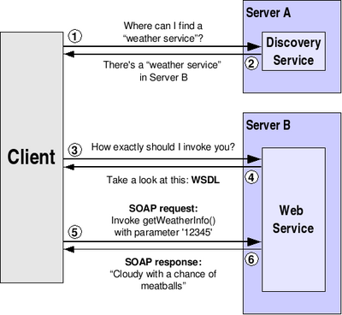

Figure 1

Structure of Web Services

**How Web Services Works?**

The basic Web services platform is XML + HTTP.

XML provides a language which can be used between different platforms and programming languages and still express complex messages and functions.

The HTTP protocol is the most used Internet protocol.

Web services platform elements:

* SOAP (Simple Object Access Protocol)
* UDDI (Universal Description, Discovery and Integration)
* WSDL (Web Services Description Language)

**Web Services are all about XML:**

1. A Web Service is described by a document in XML format, in the XML language known as WSDL (Web Services Description Language). This describes the service in terms of the operations, messages, and bindings that it contains, and may provide a URL at which the service may be called.
2. The structure of the messages is described using XML Schema (XSD) which is either contained in, or referred to by, the WSDL
3. The messages sent to, and received from, the web service are all in the form of XML that complies to the schema, and which follows the protocols described by the WSDL, using an XML protocol known as SOAP (for Simple Object Access Protocol)

The usual way to access a web service in .NET is as follows. Other platforms have similar mechanisms.

1. The developers of the web service make the WSDL accessible. They can either place it on a web site, or the web service can generate the WSDL automatically.
2. The developer of a client application will add a Service Reference if using WCF, or a Web Reference if using the older ASMX technology. This amounts to telling Visual Studio the location of the WSDL for the web service.
3. Visual Studio requests the WSDL. It parses the file to gain an understanding of the web service. From this information, it will create some classes. These are known as proxy classes (not to be confused with an Internet proxy server). These classes stand in for the web service, allowing you the illusion that you are simply calling normal methods on normal classes. But these classes are not normal.
4. The client code will create an instance of the proxy class for the service. It will call an instance method of the class, perhaps passing some parameters. The proxy class will turn these parameters into properly-formatted SOAP XML and will send them to the service.
5. On the server side, the XML will likely be turned into parameters again, and a server-side method will be called with those parameters.
6. The server will do what it was requested to do, and may then return a result. This result will be turned into SOAP XML, which will be sent back to the client.
7. The proxy class on the client will receive this XML, turn it back into return values and will return that to the caller

The result is that the caller of a web service can treat the service operations just like normal methods on normal objects. In most cases, even the developer of the web service can treat the service like it is a normal object with normal methods. But everything in the middle is happening in SOAP XML, described by XML Schema, referenced by a WSDL in XML.

**Characteristics of Web Services:**

* Machine-to-machine interactions
* Loose coupling
* Interoperability
* Platform-independence
* Operating system-independence
* Language-independence
* Leveraging the architecture of the World Wide Web

**Benefits of Web Services:**

Web Services offer many benefits over other types of distributed computing architectures.

* **Interoperability** - This is the most important benefit of Web Services. Web Services typically work outside of private networks, offering developers a non-proprietary route to their solutions. Services developed are likely, therefore, to have a longer life-span, offering better return on investment of the developed service. Web Services also let developers use their preferred programming languages. In addition, thanks to the use of standards-based communications methods, Web Services are virtually platform-independent.
* **Usability** - Web Services allow the business logic of many different systems to be exposed over the Web. This gives your applications the freedom to chose the Web Services that they need. Instead of re-inventing the wheel for each client, you need only include additional application-specific business logic on the client-side. This allows you to develop services and/or client-side code using the languages and tools that you want.
* **Reusability** - Web Services provide not a component-based model of application development, but the closest thing possible to zero-coding deployment of such services. This makes it easy to reuse Web Service components as appropriate in other services. It also makes it easy to deploy legacy code as a Web Service.
* **Deployability** - Web Services are deployed over standard Internet technologies. This makes it possible to deploy Web Services even over the fire wall to servers running on the Internet on the other side of the globe. Also thanks to the use of proven community standards, underlying security (such as SSL) is already built-in.

**2.Implementation**

**MODULES:**

* Admin
* Staff
* Users

**MODULES DESCRIPTION:**

**Admin:**

In Admin module, Admin will act as an authority. He/she can add staff details also can update. He/she can view all the toll details, entries in each tolls, online toll ticket details, user feedback about toll gates, he/she will fix the toll fare details and also he/she can update the fare details. He/she can view all the registered users. He/she can make report of users entry details.

**Staff:**

In staff module, he/she can login with the unique staff id and password. He/she can view all the online entry details in the particular toll gate. He/she can entry the vehicle details that pass through the toll gate. He/she can view all vehicle details that pass through the toll gate.

**Users:**

In Users module, Users can search Toll Gate details by enter the Keyword. After that search result will be shown to user. User can book toll ticket by online. After successful payment an automatic mail will be sent to the users mail id about the vehicle details and transaction id and also user can feedback to the selected toll gate.

**3.INPUT DESIGN AND OUTPUT DESIGN**

**INPUT DESIGN**

The input design is the link between the information system and the user. It comprises the developing specification and procedures for data preparation and those steps are necessary to put transaction data in to a usable form for processing can be achieved by inspecting the computer to read data from a written or printed document or it can occur by having people keying the data directly into the system. The design of input focuses on controlling the amount of input required, controlling the errors, avoiding delay, avoiding extra steps and keeping the process simple. The input is designed in such a way so that it provides security and ease of use with retaining the privacy. Input Design considered the following things:

* What data should be given as input?
* How the data should be arranged or coded?
* The dialog to guide the operating personnel in providing input.
* Methods for preparing input validations and steps to follow when error occur.

**OBJECTIVES**

1. Input Design is the process of converting a user-oriented description of the input into a computer-based system. This design is important to avoid errors in the data input process and show the correct direction to the management for getting correct information from the computerized system.

2. It is achieved by creating user-friendly screens for the data entry to handle large volume of data. The goal of designing input is to make data entry easier and to be free from errors. The data entry screen is designed in such a way that all the data manipulates can be performed. It also provides record viewing facilities.

3. When the data is entered it will check for its validity. Data can be entered with the help of screens. Appropriate messages are provided as when needed so that the user will not be in maize of instant. Thus the objective of input design is to create an input layout that is easy to follow

**OUTPUT DESIGN**

A quality output is one, which meets the requirements of the end user and presents the information clearly. In any system results of processing are communicated to the users and to other system through outputs. In output design it is determined how the information is to be displaced for immediate need and also the hard copy output. It is the most important and direct source information to the user. Efficient and intelligent output design improves the system’s relationship to help user decision-making.

1. Designing computer output should proceed in an organized, well thought out manner; the right output must be developed while ensuring that each output element is designed so that people will find the system can use easily and effectively. When analysis design computer output, they should Identify the specific output that is needed to meet the requirements.

2. Select methods for presenting information.

3. Create document, report, or other formats that contain information produced by the system.

The output form of an information system should accomplish one or more of the following objectives.

* Convey information about past activities, current status or projections of the
* Future.
* Signal important events, opportunities, problems, or warnings.
* Trigger an action.
* Confirm an action.

**4.LITERATURE SURVEY**

* Design is the first step in the development phase for any techniques and principles for the purpose of defining a device, a process or system in sufficient detail to permit its physical realization.
* Once the software requirements have been analyzed and specified the software design involves three technical activities - design, coding, implementation and testing that are required to build and verify the software.
* The design activities are of main importance in this phase, because in this activity, decisions ultimately affecting the success of the software implementation and its ease of maintenance are made. These decisions have the final bearing upon reliability and maintainability of the system. Design is the only way to accurately translate the customer’s requirements into finished software or a system.
* Design is the place where quality is fostered in development. Software design is a process through which requirements are translated into a representation of software. Software design is conducted in two steps. Preliminary design is concerned with the transformation of requirements into data.

**5.SOFTWARE ENVIRONMENT**

## Java Technology

Java technology is both a programming language and a platform.

### The Java Programming Language

### The Java programming language is a high-level language that can be characterized by all of the following buzzwords:

* + - Simple
    - Architecture neutral
    - Object oriented
    - Portable
    - Distributed
    - High performance
    - Interpreted
    - Multithreaded
    - Robust
    - Dynamic
    - Secure

With most programming languages, you either compile or interpret a program so that you can run it on your computer. The Java programming language is unusual in that a program is both compiled and interpreted. With the compiler, first you translate a program into an intermediate language called Java byte codes —the platform-independent codes interpreted by the interpreter on the Java platform. The interpreter parses and runs each Java byte code instruction on the computer. Compilation happens just once; interpretation occurs each time the program is executed. The following figure illustrates how this works.

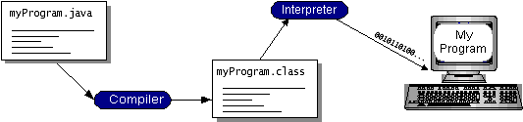

Figure 2

You can think of Java byte codes as the machine code instructions for the Java Virtual Machine (Java VM). Every Java interpreter, whether it’s a development tool or a Web browser that can run applets, is an implementation of the Java VM. Java byte codes help make “write once, run anywhere” possible. You can compile your program into byte codes on any platform that has a Java compiler. The byte codes can then be run on any implementation of the Java VM. That means that as long as a computer has a Java VM, the same program written in the Java programming language can run on Windows 2000, a Solaris workstation, or on an iMac.

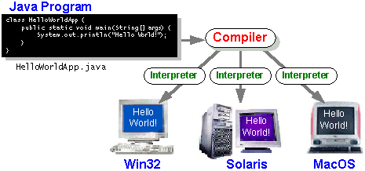

Figure 3

### The Java Platform

A platform is the hardware or software environment in which a program runs. We’ve already mentioned some of the most popular platforms like Windows 2000, Linux, Solaris, and MacOS. Most platforms can be described as a combination of the operating system and hardware. The Java platform differs from most other platforms in that it’s a software-only platform that runs on top of other hardware-based platforms.

The Java platform has two components:

* The Java Virtual Machine (Java VM)
* The Java Application Programming Interface (Java API)

You’ve already been introduced to the Java VM. It’s the base for the Java platform and is ported onto various hardware-based platforms.

The Java API is a large collection of ready-made software components that provide many useful capabilities, such as graphical user interface (GUI) widgets. The Java API is grouped into libraries of related classes and interfaces; these libraries are known as packages. The next section, What Can Java Technology Do? Highlights what functionality some of the packages in the Java API provide.

The following figure depicts a program that’s running on the Java platform. As the figure shows, the Java API and the virtual machine insulate the program from the hardware.

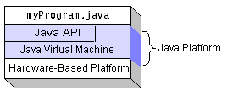

Figure 4

Native code is code that after you compile it, the compiled code runs on a specific hardware platform. As a platform-independent environment, the Java platform can be a bit slower than native code. However, smart compilers, well-tuned interpreters, and just-in-time byte code compilers can bring performance close to that of native code without threatening portability.

## What Can Java Technology Do?

The most common types of programs written in the Java programming language are applets and applications. If you’ve surfed the Web, you’re probably already familiar with applets. An applet is a program that adheres to certain conventions that allow it to run within a Java-enabled browser.

However, the Java programming language is not just for writing cute, entertaining applets for the Web. The general-purpose, high-level Java programming language is also a powerful software platform. Using the generous API, you can write many types of programs.

An application is a standalone program that runs directly on the Java platform. A special kind of application known as a server serves and supports clients on a network. Examples of servers are Web servers, proxy servers, mail servers, and print servers. Another specialized program is a servlet. A servlet can almost be thought of as an applet that runs on the server side. Java Servlets are a popular choice for building interactive web applications, replacing the use of CGI scripts. Servlets are similar to applets in that they are runtime extensions of applications. Instead of working in browsers, though, servlets run within Java Web servers, configuring or tailoring the server.

How does the API support all these kinds of programs? It does so with packages of software components that provides a wide range of functionality. Every full implementation of the Java platform gives you the following features:

* **The essentials**: Objects, strings, threads, numbers, input and output, data structures, system properties, date and time, and so on.
* **Applets**: The set of conventions used by applets.
* **Networking**: URLs, TCP (Transmission Control Protocol), UDP (User Data gram Protocol) sockets, and IP (Internet Protocol) addresses.
* **Internationalization**: Help for writing programs that can be localized for users worldwide. Programs can automatically adapt to specific locales and be displayed in the appropriate language.
* **Security**: Both low level and high level, including electronic signatures, public and private key management, access control, and certificates.
* **Software components**: Known as JavaBeansTM, can plug into existing component architectures.
* **Object serialization**: Allows lightweight persistence and communication via Remote Method Invocation (RMI).
* **Java Database Connectivity (JDBCTM)**: Provides uniform access to a wide range of relational databases.

The Java platform also has APIs for 2D and 3D graphics, accessibility, servers, collaboration, telephony, speech, animation, and more. The following figure depicts what is included in the Java 2 SDK.

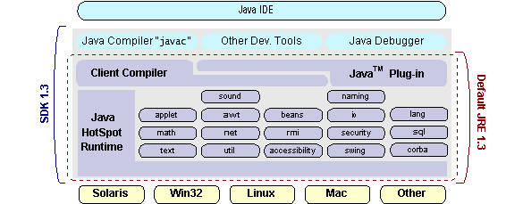

Figure 5

## How Will Java Technology Change My Life?

We can’t promise you fame, fortune, or even a job if you learn the Java programming language. Still, it is likely to make your programs better and requires less effort than other languages. We believe that Java technology will help you do the following:

* **Get started quickly**: Although the Java programming language is a powerful object-oriented language, it’s easy to learn, especially for programmers already familiar with C or C++.
* **Write less code**: Comparisons of program metrics (class counts, method counts, and so on) suggest that a program written in the Java programming language can be four times smaller than the same program in C++.
* **Write better code**: The Java programming language encourages good coding practices, and its garbage collection helps you avoid memory leaks. Its object orientation, its JavaBeans component architecture, and its wide-ranging, easily extendible API let you reuse other people’s tested code and introduce fewer bugs.
* **Develop programs more quickly**: Your development time may be as much as twice as fast versus writing the same program in C++. Why? You write fewer lines of code and it is a simpler programming language than C++.
* **Avoid platform dependencies with 100% Pure Java**: You can keep your program portable by avoiding the use of libraries written in other languages. The 100% Pure JavaTM Product Certification Program has a repository of historical process manuals, white papers, brochures, and similar materials online.
* **Write once, run anywhere**: Because 100% Pure Java programs are compiled into machine-independent byte codes, they run consistently on any Java platform.
* **Distribute software more easily**: You can upgrade applets easily from a central server. Applets take advantage of the feature of allowing new classes to be loaded “on the fly,” without recompiling the entire program.

### ODBC

Microsoft Open Database Connectivity (ODBC) is a standard programming interface for application developers and database systems providers. Before ODBC became a de facto standard for Windows programs to interface with database systems, programmers had to use proprietary languages for each database they wanted to connect to. Now, ODBC has made the choice of the database system almost irrelevant from a coding perspective, which is as it should be. Application developers have much more important things to worry about than the syntax that is needed to port their program from one database to another when business needs suddenly change.

Through the ODBC Administrator in Control Panel, you can specify the particular database that is associated with a data source that an ODBC application program is written to use. Think of an ODBC data source as a door with a name on it. Each door will lead you to a particular database. For example, the data source named Sales Figures might be a SQL Server database, whereas the Accounts Payable data source could refer to an Access database. The physical database referred to by a data source can reside anywhere on the LAN.

The ODBC system files are not installed on your system by Windows 95. Rather, they are installed when you setup a separate database application, such as SQL Server Client or Visual Basic 4.0. When the ODBC icon is installed in Control Panel, it uses a file called ODBCINST.DLL. It is also possible to administer your ODBC data sources through a stand-alone program called ODBCADM.EXE. There is a 16-bit and a 32-bit version of this program and each maintains a separate list of ODBC data sources.

From a programming perspective, the beauty of ODBC is that the application can be written to use the same set of function calls to interface with any data source, regardless of the database vendor. The source code of the application doesn’t change whether it talks to Oracle or SQL Server. We only mention these two as an example. There are ODBC drivers available for several dozen popular database systems. Even Excel spreadsheets and plain text files can be turned into data sources. The operating system uses the Registry information written by ODBC Administrator to determine which low-level ODBC drivers are needed to talk to the data source (such as the interface to Oracle or SQL Server). The loading of the ODBC drivers is transparent to the ODBC application program. In a client/server environment, the ODBC API even handles many of the network issues for the application programmer.

The advantages of this scheme are so numerous that you are probably thinking there must be some catch. The only disadvantage of ODBC is that it isn’t as efficient as talking directly to the native database interface. ODBC has had many detractors make the charge that it is too slow. Microsoft has always claimed that the critical factor in performance is the quality of the driver software that is used. In our humble opinion, this is true. The availability of good ODBC drivers has improved a great deal recently. And anyway, the criticism about performance is somewhat analogous to those who said that compilers would never match the speed of pure assembly language. Maybe not, but the compiler (or ODBC) gives you the opportunity to write cleaner programs, which means you finish sooner. Meanwhile, computers get faster every year.

**JDBC**

In an effort to set an independent database standard API for Java; Sun Microsystems developed Java Database Connectivity, or JDBC. JDBC offers a generic SQL database access mechanism that provides a consistent interface to a variety of RDBMSs. This consistent interface is achieved through the use of “plug-in” database connectivity modules, or drivers. If a database vendor wishes to have JDBC support, he or she must provide the driver for each platform that the database and Java run on.

To gain a wider acceptance of JDBC, Sun based JDBC’s framework on ODBC. As you discovered earlier in this chapter, ODBC has widespread support on a variety of platforms. Basing JDBC on ODBC will allow vendors to bring JDBC drivers to market much faster than developing a completely new connectivity solution.

JDBC was announced in March of 1996. It was released for a 90 day public review that ended June 8, 1996. Because of user input, the final JDBC v1.0 specification was released soon after.

The remainder of this section will cover enough information about JDBC for you to know what it is about and how to use it effectively. This is by no means a complete overview of JDBC. That would fill an entire book.

### JDBC Goals

Few software packages are designed without goals in mind. JDBC is one that, because of its many goals, drove the development of the API. These goals, in conjunction with early reviewer feedback, have finalized the JDBC class library into a solid framework for building database applications in Java.

The goals that were set for JDBC are important. They will give you some insight as to why certain classes and functionalities behave the way they do. The eight design goals for JDBC are as follows:

1. ***SQL Level API***

The designers felt that their main goal was to define a SQL interface for Java. Although not the lowest database interface level possible, it is at a low enough level for higher-level tools and APIs to be created. Conversely, it is at a high enough level for application programmers to use it confidently. Attaining this goal allows for future tool vendors to “generate” JDBC code and to hide many of JDBC’s complexities from the end user.

1. ***SQL Conformance***

SQL syntax varies as you move from database vendor to database vendor. In an effort to support a wide variety of vendors, JDBC will allow any query statement to be passed through it to the underlying database driver. This allows the connectivity module to handle non-standard functionality in a manner that is suitable for its users.

1. ***JDBC must be implemental on top of common database interfaces***The JDBC SQL API must “sit” on top of other common SQL level APIs. This goal allows JDBC to use existing ODBC level drivers by the use of a software interface. This interface would translate JDBC calls to ODBC and vice versa.
2. ***Provide a Java interface that is consistent with the rest of the Java system***

Because of Java’s acceptance in the user community thus far, the designers feel that they should not stray from the current design of the core Java system.

1. ***Keep it simple***

This goal probably appears in all software design goal listings. JDBC is no exception. Sun felt that the design of JDBC should be very simple, allowing for only one method of completing a task per mechanism. Allowing duplicate functionality only serves to confuse the users of the API.

1. ***Use strong, static typing wherever possible***

Strong typing allows for more error checking to be done at compile time; also, less error appear at runtime.

1. ***Keep the common cases simple***

Because more often than not, the usual SQL calls used by the programmer are simple SELECT’s, INSERT’s, DELETE’s and UPDATE’s, these queries should be simple to perform with JDBC. However, more complex SQL statements should also be possible.

Finally we decided to proceed the implementation using Java Networking.

And for dynamically updating the cache table we go for MS Access database.

Java ha two things: a programming language and a platform.

Java is a high-level programming language that is all of the following

Simple Architecture-neutral

Object-oriented Portable

Distributed High-performance

Interpreted multithreaded

Robust Dynamic

Secure

Java is also unusual in that each Java program is both compiled and interpreted. With a compile you translate a Java program into an intermediate language called Java byte codes the platform-independent code instruction is passed and run on the computer.

Compilation happens just once; interpretation occurs each time the program is executed. The figure illustrates how this works.

**Java Program**

**Compilers**

**Interpreter**

**My Program**

Figure 6

You can think of Java byte codes as the machine code instructions for the Java Virtual Machine (Java VM). Every Java interpreter, whether it’s a Java development tool or a Web browser that can run Java applets, is an implementation of the Java VM. The Java VM can also be implemented in hardware.

Java byte codes help make “write once, run anywhere” possible. You can compile your Java program into byte codes on my platform that has a Java compiler. The byte codes can then be run any implementation of the Java VM. For example, the same Java program can run Windows NT, Solaris, and Macintosh.

## Networking

### TCP/IP stack

The TCP/IP stack is shorter than the OSI one:

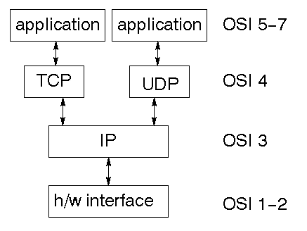

Figure 7

TCP is a connection-oriented protocol; UDP (User Datagram Protocol) is a connectionless protocol.

### IP datagram’s

The IP layer provides a connectionless and unreliable delivery system. It considers each datagram independently of the others. Any association between datagram must be supplied by the higher layers. The IP layer supplies a checksum that includes its own header. The header includes the source and destination addresses. The IP layer handles routing through an Internet. It is also responsible for breaking up large datagram into smaller ones for transmission and reassembling them at the other end.

### UDP

UDP is also connectionless and unreliable. What it adds to IP is a checksum for the contents of the datagram and port numbers. These are used to give a client/server model - see later.

### TCP

TCP supplies logic to give a reliable connection-oriented protocol above IP. It provides a virtual circuit that two processes can use to communicate.

### Internet addresses

In order to use a service, you must be able to find it. The Internet uses an address scheme for machines so that they can be located. The address is a 32 bit integer which gives the IP address. This encodes a network ID and more addressing. The network ID falls into various classes according to the size of the network address.

### Network address

Class A uses 8 bits for the network address with 24 bits left over for other addressing. Class B uses 16 bit network addressing. Class C uses 24 bit network addressing and class D uses all 32.

### Subnet address

Internally, the UNIX network is divided into sub networks. Building 11 is currently on one sub network and uses 10-bit addressing, allowing 1024 different hosts.

### Host address

8 bits are finally used for host addresses within our subnet. This places a limit of 256 machines that can be on the subnet.

### Total address

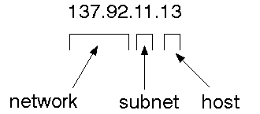

The 32 bit address is usually written as 4 integers separated by dots.

### Port addresses

A service exists on a host, and is identified by its port. This is a 16 bit number. To send a message to a server, you send it to the port for that service of the host that it is running on. This is not location transparency! Certain of these ports are "well known".

### Sockets

A socket is a data structure maintained by the system to handle network connections. A socket is created using the call socket. It returns an integer that is like a file descriptor. In fact, under Windows, this handle can be used with Read File and Write File functions.

#include <sys/types.h>

#include <sys/socket.h>

int socket(int family, int type, int protocol);

Here "family" will be AF_INET for IP communications, protocol will be zero, and type will depend on whether TCP or UDP is used. Two processes wishing to communicate over a network create a socket each. These are similar to two ends of a pipe - but the actual pipe does not yet exist.

**JFree Chart**

JFreeChart is a free 100% Java chart library that makes it easy for developers to display professional quality charts in their applications. JFreeChart's extensive feature set includes:

A consistent and well-documented API, supporting a wide range of chart types;

A flexible design that is easy to extend, and targets both server-side and client-side applications;

Support for many output types, including Swing components, image files (including PNG and JPEG), and vector graphics file formats (including PDF, EPS and SVG);

JFreeChart is "open source" or, more specifically, free software. It is distributed under the terms of the GNU Lesser General Public Licence (LGPL), which permits use in proprietary applications.

## 1. Map Visualizations

Charts showing values that relate to geographical areas. Some examples include: (a) population density in each state of the United States, (b) income per capita for each country in Europe, (c) life expectancy in each country of the world. The tasks in this project include:

Sourcing freely redistributable vector outlines for the countries of the world, states/provinces in particular countries (USA in particular, but also other areas);

Creating an appropriate dataset interface (plus default implementation), a rendered, and integrating this with the existing XYPlot class in JFreeChart;

Testing, documenting, testing some more, documenting some more.

## 2. Time Series Chart Interactivity

Implement a new (to JFreeChart) feature for interactive time series charts --- to display a separate control that shows a small version of ALL the time series data, with a sliding "view" rectangle that allows you to select the subset of the time series data to display in the main chart.

## 3. Dashboards

There is currently a lot of interest in dashboard displays. Create a flexible dashboard mechanism that supports a subset of JFreeChart chart types (dials, pies, thermometers, bars, and lines/time series) that can be delivered easily via both Java Web Start and an applet.

## 4. Property Editors

The property editor mechanism in JFreeChart only handles a small subset of the properties that can be set for charts. Extend (or reimplement) this mechanism to provide greater end-user control over the appearance of the charts.

**J2ME (Java 2 Micro edition):-**

Sun Microsystems defines J2ME as "a highly optimized Java run-time environment targeting a wide range of consumer products, including pagers, cellular phones, screen-phones, digital set-top boxes and car navigation systems." Announced in June 1999 at the JavaOne Developer Conference, J2ME brings the cross-platform functionality of the Java language to smaller devices, allowing mobile wireless devices to share applications. With J2ME, Sun has adapted the Java platform for consumer products that incorporate or are based on small computing devices.

**1. General J2ME architecture**



Figure 8

J2ME uses configurations and profiles to customize the Java Runtime Environment (JRE). As a complete JRE, J2ME is comprised of a configuration, which determines the JVM used, and a profile, which defines the application by adding domain-specific classes. The configuration defines the basic run-time environment as a set of core classes and a specific JVM that run on specific types of devices. We'll discuss configurations in detail in the The profile defines the application; specifically, it adds domain-specific classes to the J2ME configuration to define certain uses for devices. We'll cover profiles in depth in the The following graphic depicts the relationship between the different virtual machines, configurations, and profiles. It also draws a parallel with the J2SE API and its Java virtual machine. While the J2SE virtual machine is generally referred to as a JVM, the J2ME virtual machines, KVM and CVM, are subsets of JVM. Both KVM and CVM can be thought of as a kind of Java virtual machine -- it's just that they are shrunken versions of the J2SE JVM and are specific to J2ME.

**2. Developing J2ME applications**

Introduction In this section, we will go over some considerations you need to keep in mind when developing applications for smaller devices. We'll take a look at the way the compiler is invoked when using J2SE to compile J2ME applications. Finally, we'll explore packaging and deployment and the role preverification plays in this process.

**3. Design considerations for small devices**

Developing applications for small devices requires you to keep certain strategies in mind during the design phase. It is best to strategically design an application for a small device before you begin coding. Correcting the code because you failed to consider all of the "gotchas" before developing the application can be a painful process. Here are some design strategies to consider:

* Keep it simple. Remove unnecessary features, possibly making those features a separate, secondary application.

* Smaller is better. This consideration should be a "no brainer" for all developers. Smaller applications use less memory on the device and require shorter installation times. Consider packaging your Java applications as compressed Java Archive (jar) files.

* Minimize run-time memory use. To minimize the amount of memory used at run time, use scalar types in place of object types. Also, do not depend on the garbage collector. You should manage the memory efficiently yourself by setting object references to null when you are finished with them. Another way to reduce run-time memory is to use lazy instantiation, only allocating objects on an as-needed basis. Other ways of reducing overall and peak memory use on small devices are to release resources quickly, reuse objects, and avoid exceptions.

**4. Configurations overview**

The configuration defines the basic run-time environment as a set of core classes and a specific JVM that run on specific types of devices. Currently, two configurations exist for J2ME, though others may be defined in the future:

* **Connected Limited Device Configuration (CLDC)** is used specifically with the KVM for 16-bit or 32-bit devices with limited amounts of memory. This is the configuration (and the virtual machine) used for developing small J2ME applications. Its size limitations make CLDC more interesting and challenging (from a development point of view) than CDC. CLDC is also the configuration that we will use for developing our drawing tool application. An example of a small wireless device running small applications is a Palm hand-held computer.

* **Connected Device Configuration (CDC)** is used with the C virtual machine (CVM) and is used for 32-bit architectures requiring more than 2 MB of memory. An example of such a device is a Net TV box.

**5. J2ME profiles**

**What is a J2ME profile?**

As we mentioned earlier in this tutorial, a profile defines the type of device supported. The Mobile Information Device Profile (MIDP), for example, defines classes for cellular phones. It adds domain-specific classes to the J2ME configuration to define uses for similar devices. Two profiles have been defined for J2ME and are built upon CLDC: KJava and MIDP. Both KJava and MIDP are associated with CLDC and smaller devices. Profiles are built on top of configurations. Because profiles are specific to the size of the device (amount of memory) on which an application runs, certain profiles are associated with certain configurations.

A skeleton profile upon which you can create your own profile, the Foundation Profile, is available for CDC.

**Profile 1: KJava**

KJava is Sun's proprietary profile and contains the KJava API. The KJava profile is built on top of the CLDC configuration. The KJava virtual machine, KVM, accepts the same byte codes and class file format as the classic J2SE virtual machine. KJava contains a Sun-specific API that runs on the Palm OS. The KJava API has a great deal in common with the J2SE Abstract Windowing Toolkit (AWT). However, because it is not a standard J2ME package, its main package is com.sun.kjava. We'll learn more about the KJava API later in this tutorial when we develop some sample applications.

**Profile 2: MIDP**

MIDP is geared toward mobile devices such as cellular phones and pagers. The MIDP, like KJava, is built upon CLDC and provides a standard run-time environment that allows new applications and services to be deployed dynamically on end user devices. MIDP is a common, industry-standard profile for mobile devices that is not dependent on a specific vendor. It is a complete and supported foundation for mobile application

development. MIDP contains the following packages, the first three of which are core CLDC packages, plus three MIDP-specific packages.

* java.lang

* java.io

* java.util

* javax.microedition.io

* javax.microedition.lcdui

* javax.microedition.midlet

* javax.microedition.rms

**6.SYSTEM DESIGN**

**DATA FLOW DIAGRAM:**

1. The DFD is also called as bubble chart. It is a simple graphical formalism that can be used to represent a system in terms of input data to the system, various processing carried out on this data, and the output data is generated by this system.
2. The data flow diagram (DFD) is one of the most important modeling tools. It is used to model the system components. These components are the system process, the data used by the process, an external entity that interacts with the system and the information flows in the system.
3. DFD shows how the information moves through the system and how it is modified by a series of transformations. It is a graphical technique that depicts information flow and the transformations that are applied as data moves from input to output.
4. DFD is also known as bubble chart. A DFD may be used to represent a system at any level of abstraction. DFD may be partitioned into levels that represent increasing

**Admin:**

Admin

Check

Unauthorized user

Update Profile

View Toll details

View Toll Entries

View Toll Feedbacks

Fare Details and Update

Add Staff

View Staff details & update

View Users details

End process

Figure 9

**Staff:**

Figure 10

Unauthorized user

Staff

Check

Enter Vehicle Details

View daily Entries

Online Ticket details

End process

No

yes

**User:**

Figure 11

Unauthorized user

User

Check

No

Yes

Search Toll Gate

View Results

Book Toll ticket

Make payment

End process

Write Feedbacks

**7.UML DIAGRAMS**

UML stands for Unified Modeling Language. UML is a standardized general-purpose modeling language in the field of object-oriented software engineering. The standard is managed, and was created by, the Object Management Group.

The goal is for UML to become a common language for creating models of object oriented computer software. In its current form UML is comprised of two major components: a Meta-model and a notation. In the future, some form of method or process may also be added to; or associated with, UML.

The Unified Modeling Language is a standard language for specifying, Visualization, Constructing and documenting the artifacts of software system, as well as for business modeling and other non-software systems.

The UML represents a collection of best engineering practices that have proven successful in the modeling of large and complex systems.

The UML is a very important part of developing objects oriented software and the software development process. The UML uses mostly graphical notations to express the design of software projects.

**GOALS:**

The Primary goals in the design of the UML are as follows:

1. Provide users a ready-to-use, expressive visual modeling Language so that they can develop and exchange meaningful models.
2. Provide extendibility and specialization mechanisms to extend the core concepts.
3. Be independent of particular programming languages and development process.
4. Provide a formal basis for understanding the modeling language.
5. Encourage the growth of OO tools market.
6. Support higher level development concepts such as collaborations, frameworks, patterns and components.
7. Integrate best practices.

**USE CASE DIAGRAM:**

A use case diagram in the Unified Modeling Language (UML) is a type of behavioral diagram defined by and created from a Use-case analysis. Its purpose is to present a graphical overview of the functionality provided by a system in terms of actors, their goals (represented as use cases), and any dependencies between those use cases. The main purpose of a use case diagram is to show what system functions are performed for which actor. Roles of the actors in the system can be depicted.

Figure 12

View User Details ()

View Owners Details ()

View Uploaded Files on Cloud Server()

Cloud

Login

Upload Files ()

View Uploaded Files ()

View File Request by Users ()

Approve File Request ()

Data Owner

Login

View Files uploaded by Data Owners()

Send File Request ()

Verify key Sent by data Owner ()

View requested File()

Data User

Login

Add staff ()

View Staff and update ()

View and update fare ()

View users details ()

View users feedbacks ()

View entry details ()

Admin

Login

Enter Vehicle Details ()

View daily entries ()

View online ticket details ()

Staff

Login

Search Toll Gate ()

Write Review ()

Book tickets ()

User

Login

Figure 13

Staff

LOGIN

Start

Enter Vehicle Details, View daily entries, View online ticket details

Users

LOGIN

Search Toll Gate, view result, Write Review, Book tickets

Admin

LOGIN

Add staff, View Staff and update, View and update fare, View users details, View users feedbacks, View entry details

Figure 14

Staff

User

Admin

View Users details

DATA BASE

SERVICE

**8.SYSTEM STUDY**

**FEASIBILITY STUDY**

The feasibility of the project is analyzed in this phase and business proposal is put forth with a very general plan for the project and some cost estimates. During system analysis the feasibility study of the proposed system is to be carried out. This is to ensure that the proposed system is not a burden to the company. For feasibility analysis, some understanding of the major requirements for the system is essential.

Three key considerations involved in the feasibility analysis are

* ECONOMICAL FEASIBILITY
* TECHNICAL FEASIBILITY
* SOCIAL FEASIBILITY

**ECONOMICAL FEASIBILITY**

This study is carried out to check the economic impact that the system will have on the organization. The amount of fund that the company can pour into the research and development of the system is limited. The expenditures must be justified. Thus the developed system as well within the budget and this was achieved because most of the technologies used are freely available. Only the customized products had to be purchased.

### TECHNICAL FEASIBILITY

This study is carried out to check the technical feasibility, that is, the technical requirements of the system. Any system developed must not have a high demand on the available technical resources. This will lead to high demands on the available technical resources. This will lead to high demands being placed on the client. The developed system must have a modest requirement, as only minimal or null changes are required for implementing this system.

**SOCIAL FEASIBILITY**

The aspect of study is to check the level of acceptance of the system by the user. This includes the process of training the user to use the system efficiently. The user must not feel threatened by the system, instead must accept it as a necessity. The level of acceptance by the users solely depends on the methods that are employed to educate the user about the system and to make him familiar with it. His level of confidence must be raised so that he is also able to make some constructive criticism, which is welcomed, as he is the final user of the system.

### SYSTEM TESTING

The purpose of testing is to discover errors. Testing is the process of trying to discover every conceivable fault or weakness in a work product. It provides a way to check the functionality of components, sub assemblies, assemblies and/or a finished product It is the process of exercising software with the intent of ensuring that the

Software system meets its requirements and user expectations and does not fail in an unacceptable manner. There are various types of test. Each test type addresses a specific testing requirement.

**TYPES OF TESTS**

**Unit testing**

Unit testing involves the design of test cases that validate that the internal program logic is functioning properly, and that program inputs produce valid outputs. All decision branches and internal code flow should be validated. It is the testing of individual software units of the application .it is done after the completion of an individual unit before integration. This is a structural testing, that relies on knowledge of its construction and is invasive. Unit tests perform basic tests at component level and test a specific business process, application, and/or system configuration. Unit tests ensure that each unique path of a business process performs accurately to the documented specifications and contains clearly defined inputs and expected results.

**Integration testing**

Integration tests are designed to test integrated software components to determine if they actually run as one program. Testing is event driven and is more concerned with the basic outcome of screens or fields. Integration tests demonstrate that although the components were individually satisfaction, as shown by successfully unit testing, the combination of components is correct and consistent. Integration testing is specifically aimed at exposing the problems that arise from the combination of components.

**Functional test**

Functional tests provide systematic demonstrations that functions tested are available as specified by the business and technical requirements, system documentation, and user manuals.

Functional testing is centered on the following items:

Valid Input : identified classes of valid input must be accepted.

Invalid Input : identified classes of invalid input must be rejected.

Functions : identified functions must be exercised.

Output : identified classes of application outputs must be exercised.

Systems/Procedures: interfacing systems or procedures must be invoked.

Organization and preparation of functional tests is focused on requirements, key functions, or special test cases. In addition, systematic coverage pertaining to identify Business process flows; data fields, predefined processes, and successive processes must be considered for testing. Before functional testing is complete, additional tests are identified and the effective value of current tests is determined.

**System Test**

System testing ensures that the entire integrated software system meets requirements. It tests a configuration to ensure known and predictable results. An example of system testing is the configuration oriented system integration test. System testing is based on process descriptions and flows, emphasizing pre-driven process links and integration points.

**White Box Testing**

White Box Testing is a testing in which in which the software tester has knowledge of the inner workings, structure and language of the software, or at least its purpose. It is purpose. It is used to test areas that cannot be reached from a black box level.

**Black Box Testing**

Black Box Testing is testing the software without any knowledge of the inner workings, structure or language of the module being tested. Black box tests, as most other kinds of tests, must be written from a definitive source document, such as specification or requirements document, such as specification or requirements document. It is a testing in which the software under test is treated, as a black box .you cannot “see” into it. The test provides inputs and responds to outputs without considering how the software works.

**Unit Testing:**

Unit testing is usually conducted as part of a combined code and unit test phase of the software lifecycle, although it is not uncommon for coding and unit testing to be conducted as two distinct phases.

**Test strategy and approach**

Field testing will be performed manually and functional tests will be written in detail.

**Test objectives**

* All field entries must work properly.
* Pages must be activated from the identified link.
* The entry screen, messages and responses must not be delayed.

**Features to be tested**

* Verify that the entries are of the correct format
* No duplicate entries should be allowed
* All links should take the user to the correct page.

# Integration Testing

Software integration testing is the incremental integration testing of two or more integrated software components on a single platform to produce failures caused by interface defects.

The task of the integration test is to check that components or software applications, e.g. components in a software system or – one step up – software applications at the company level – interact without error.

**Test Results:** All the test cases mentioned above passed successfully. No defects encountered.

**Acceptance Testing**

User Acceptance Testing is a critical phase of any project and requires significant participation by the end user. It also ensures that the system meets the functional requirements.

**Test Results:** All the test cases mentioned above passed successfully. No defects encountered.

9.OUTPUT IMAGES

**Home Page:**

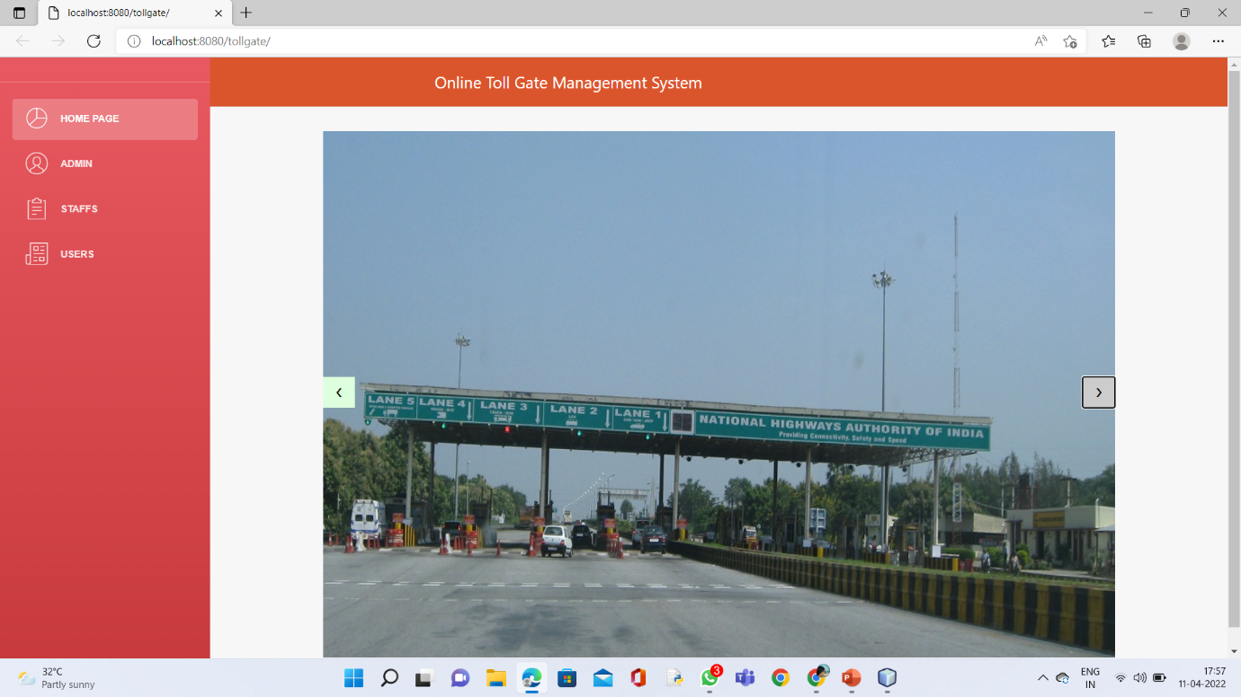

Figure 15

**Admin Login Page:**

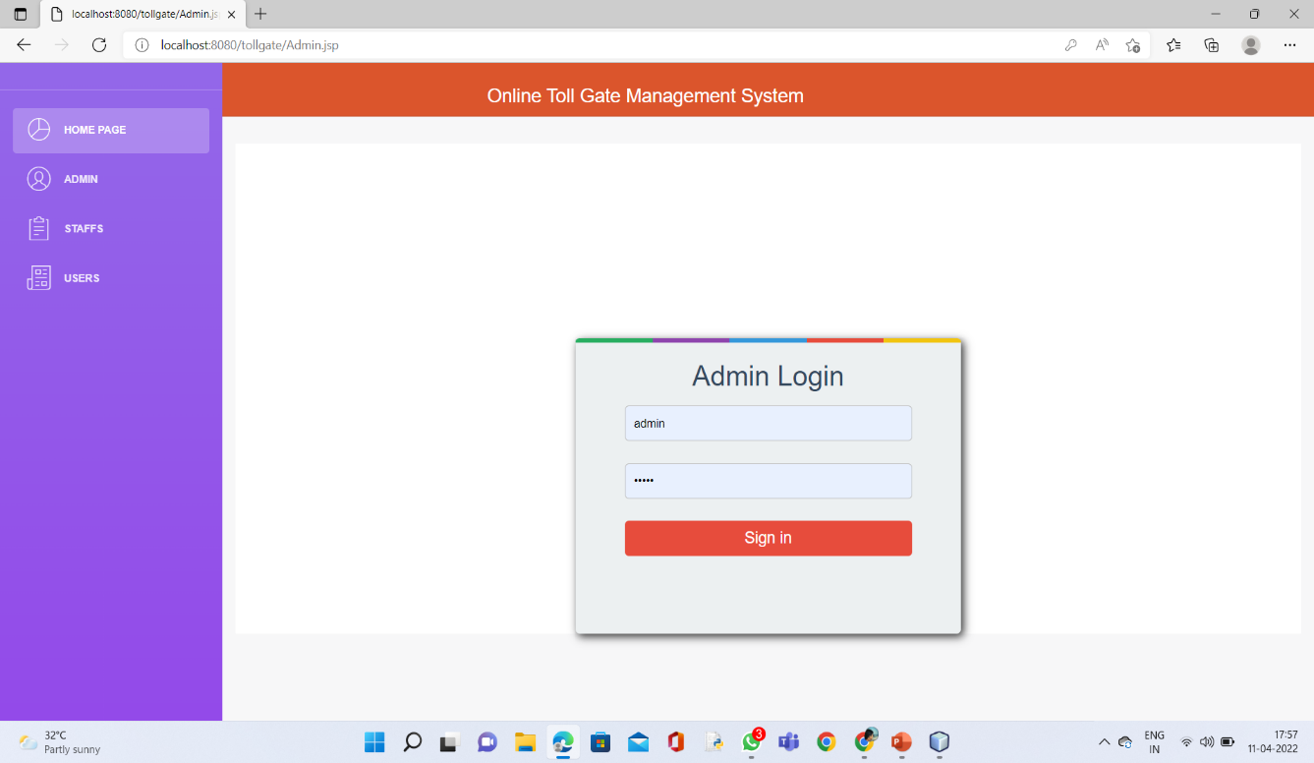

Figure 16

**Staff Login Page:** 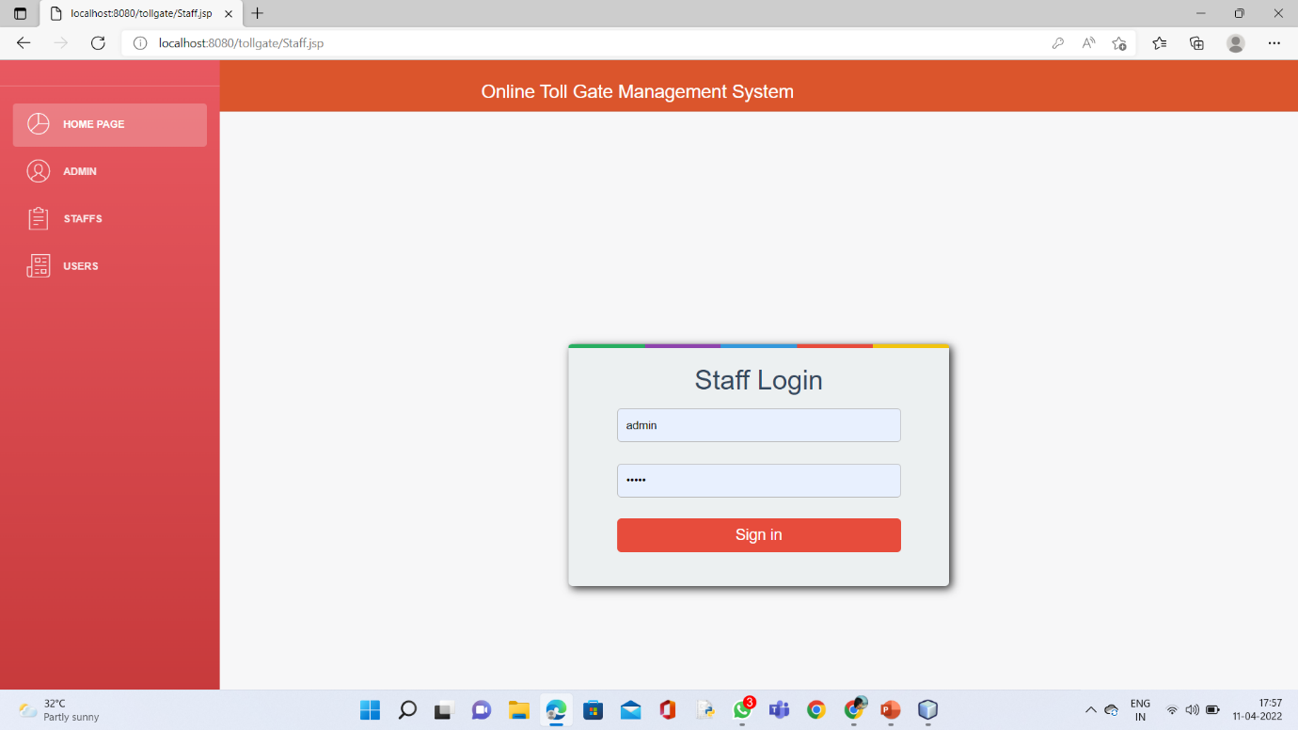

Figure 17

**User Login Page:**

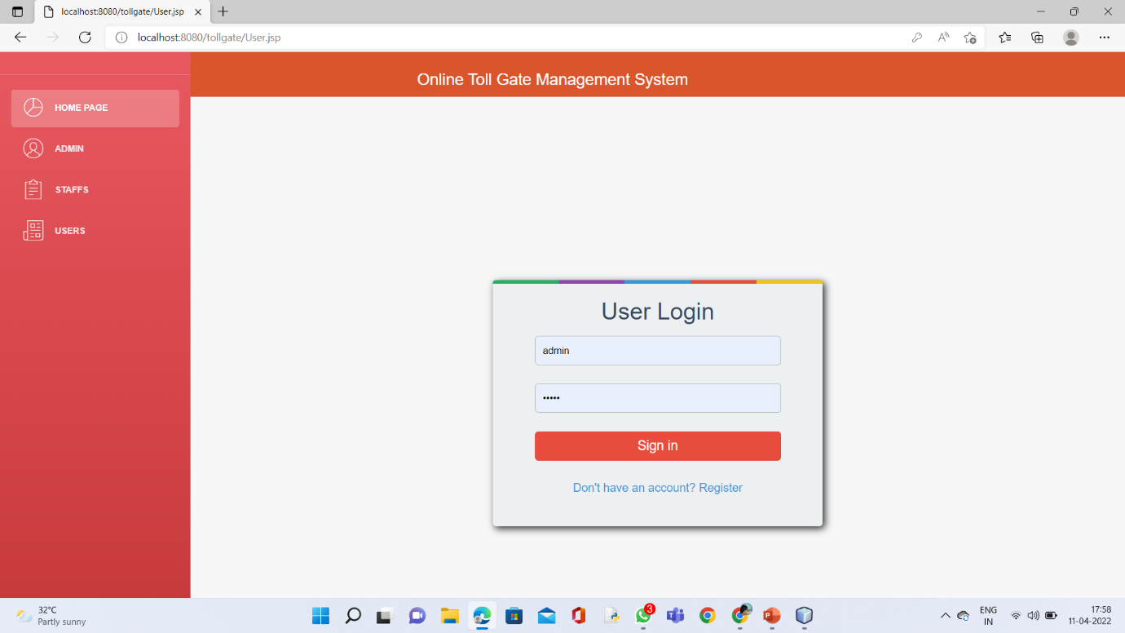

Figure 18

**Admin Home Page:**

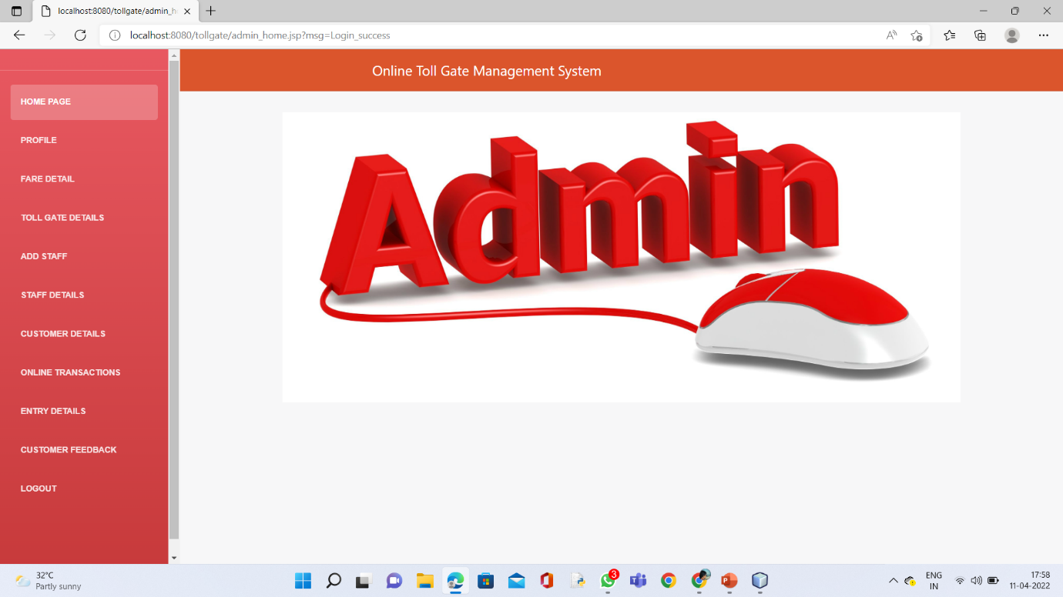

Figure 19

**Admin Profile Edit Page:**

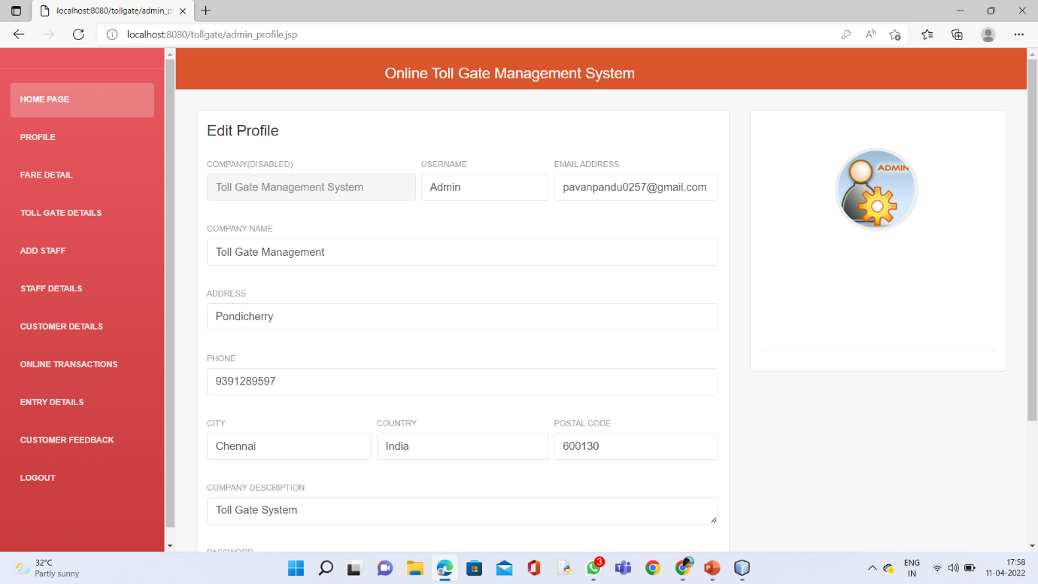

Figure 20

Fare Details Page:

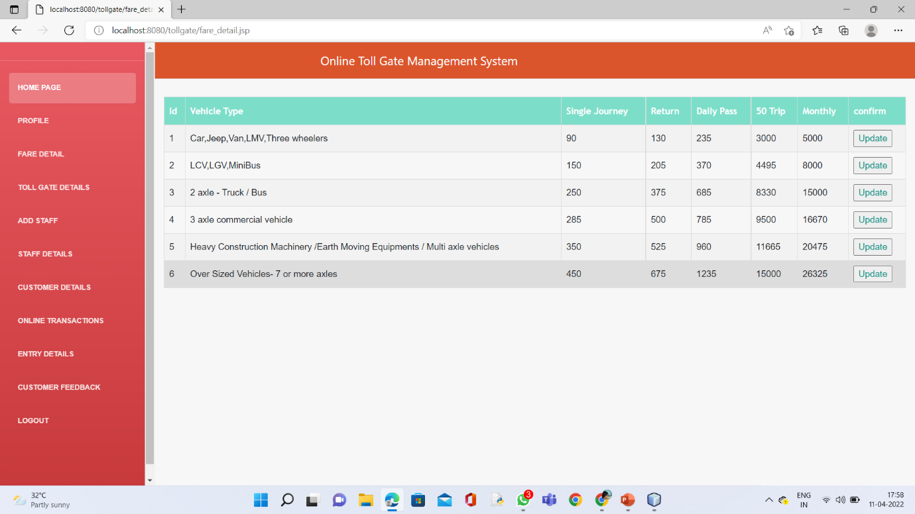

Figure 21

Toll Gate Details : 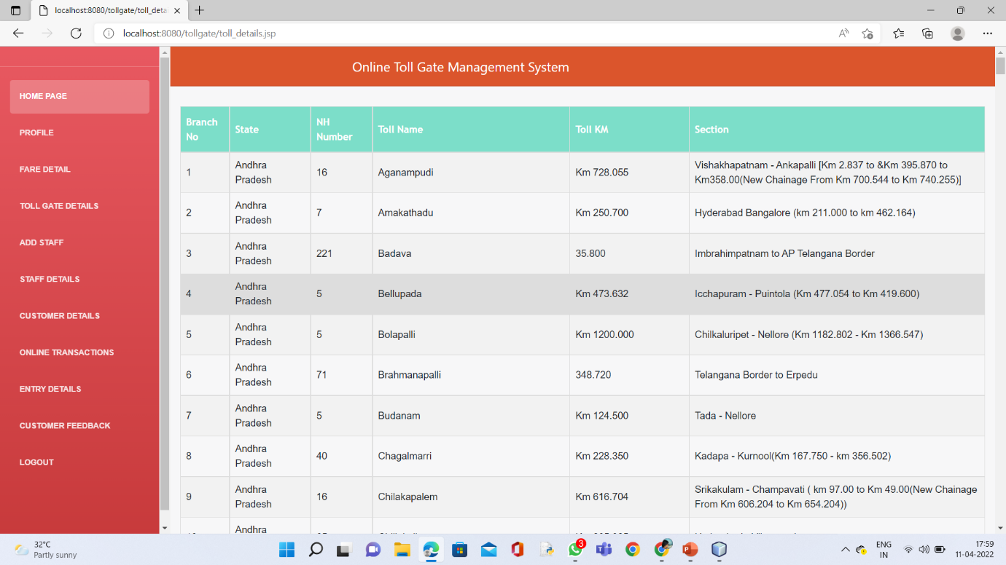

Figure 22

Add Staff :

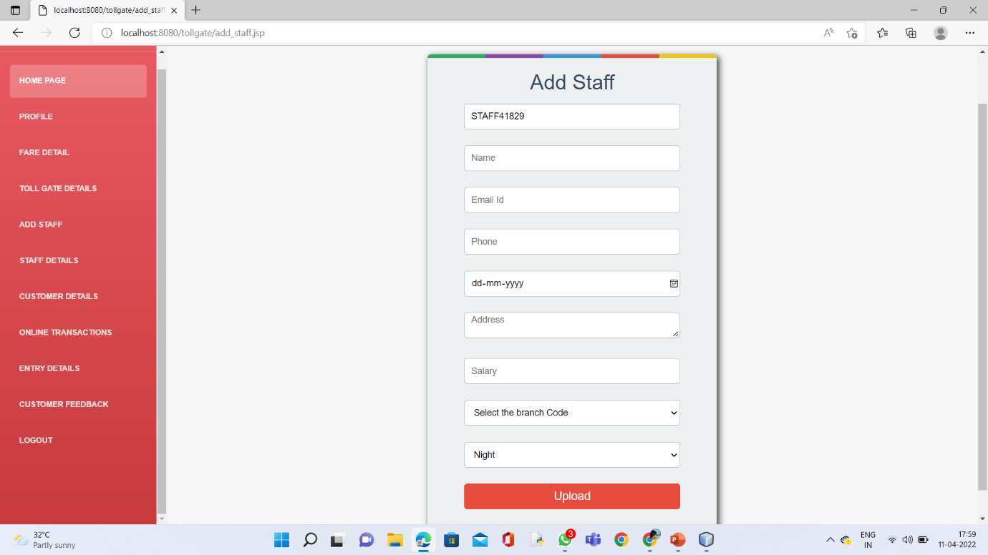

Figure 23

Staff Details:

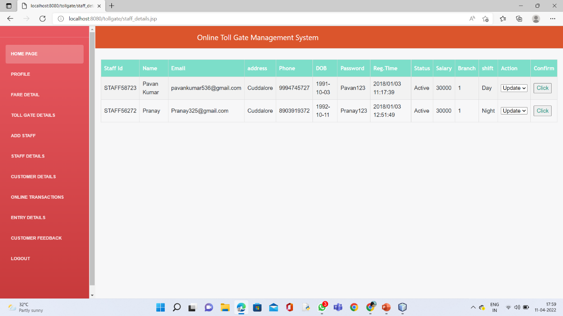

Figure 24

Customer Details:

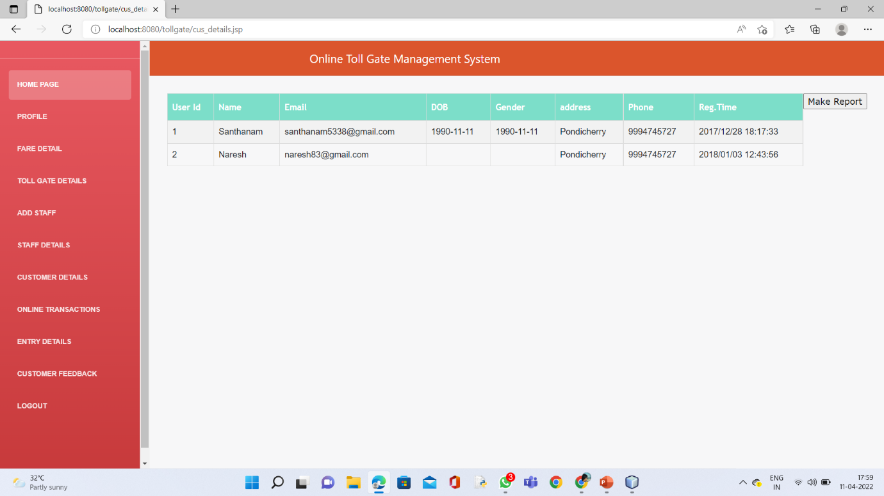

Figure 25

Online Transations: 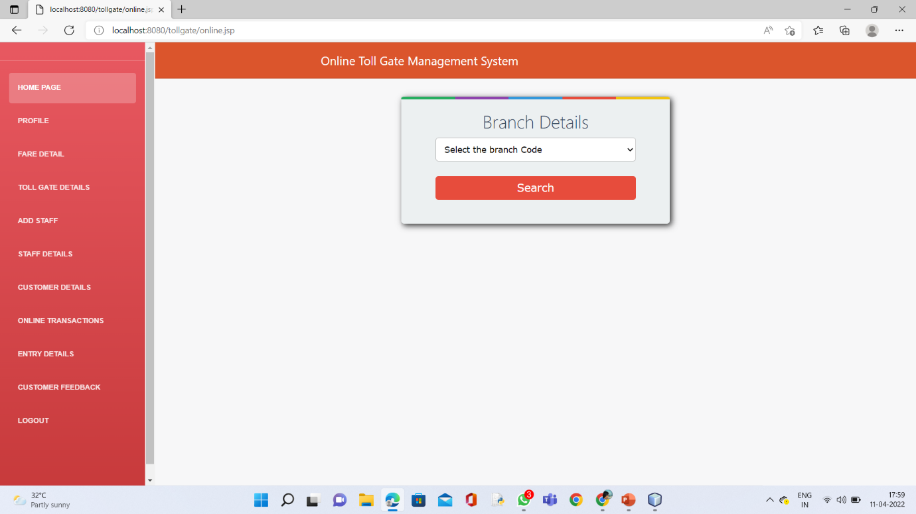

Figure 26

Entry Details: 

Figure 27

Customer Feedback:

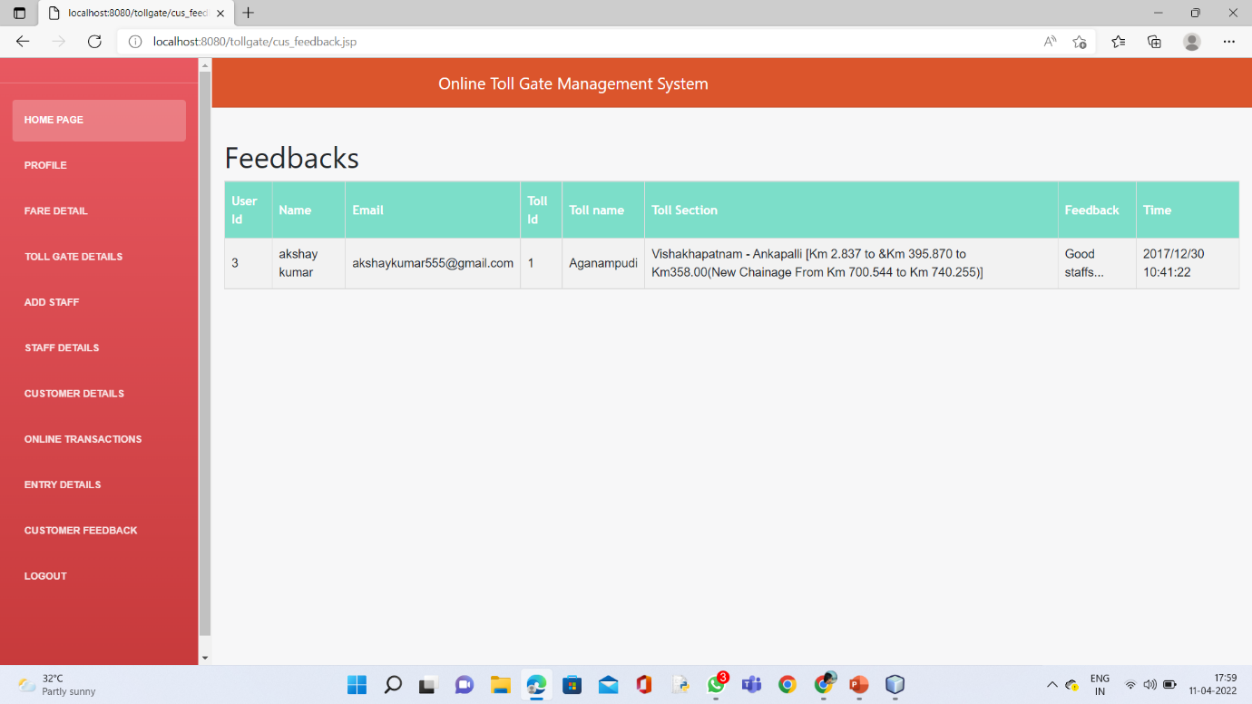

Figure 28

Staff Home Page:

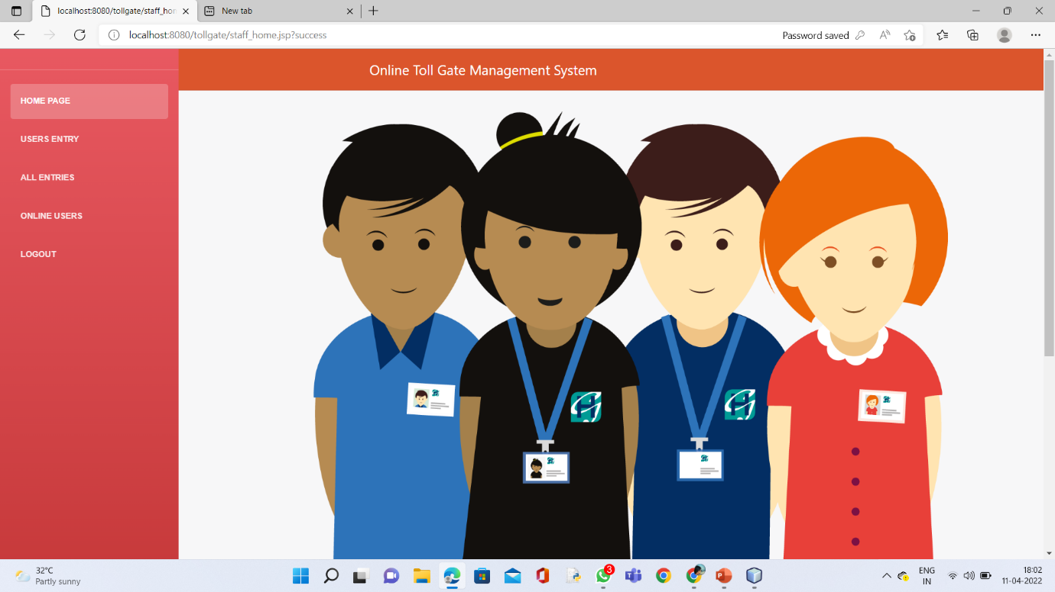

Figure 29

Users Entry:

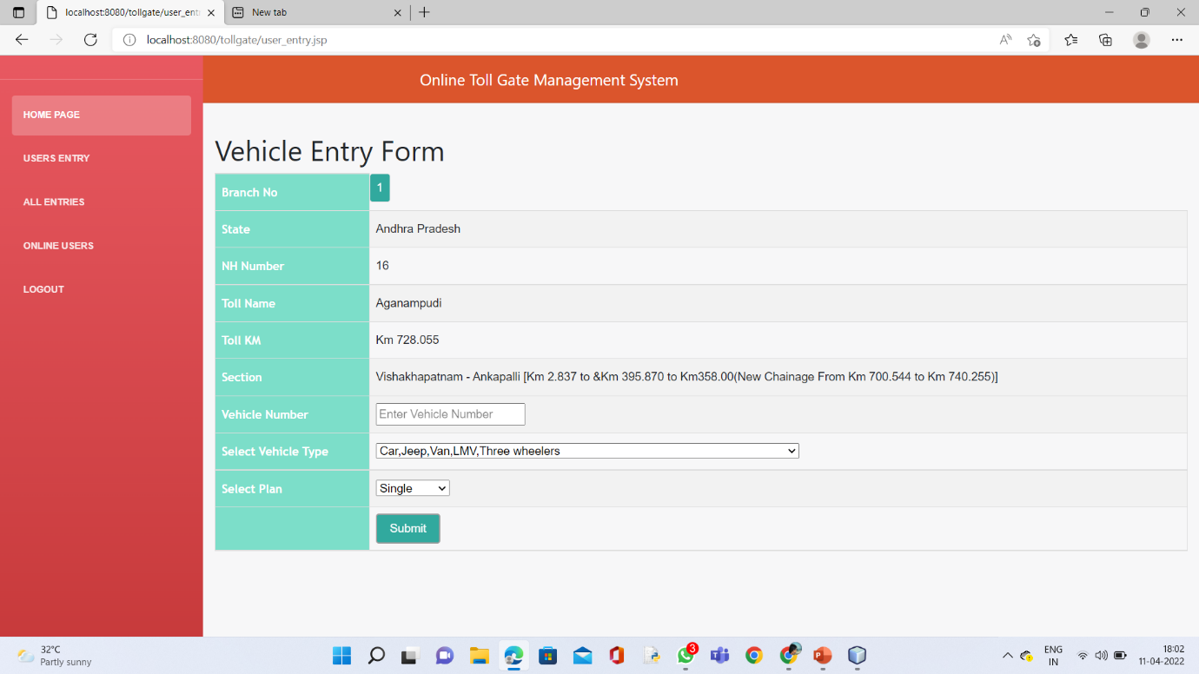

Figure 30

Staff Payment Page:

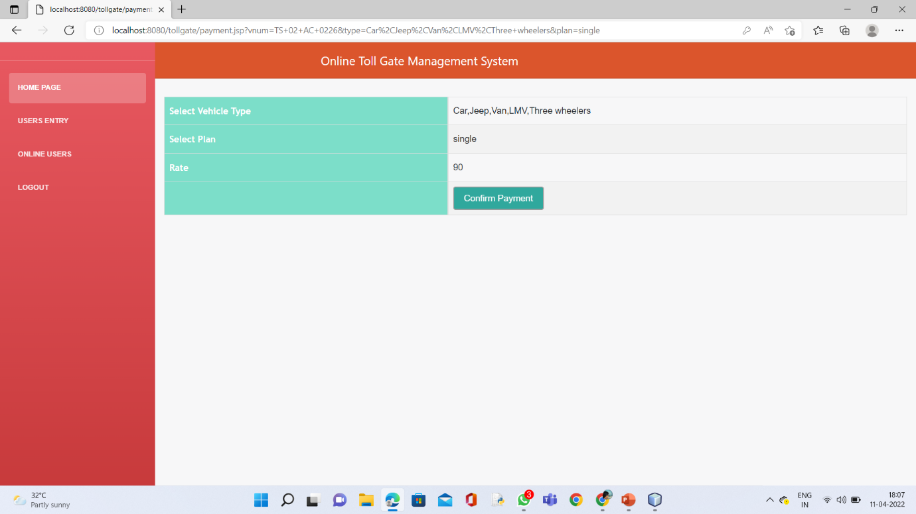

Figure 31

All ENTRIES:

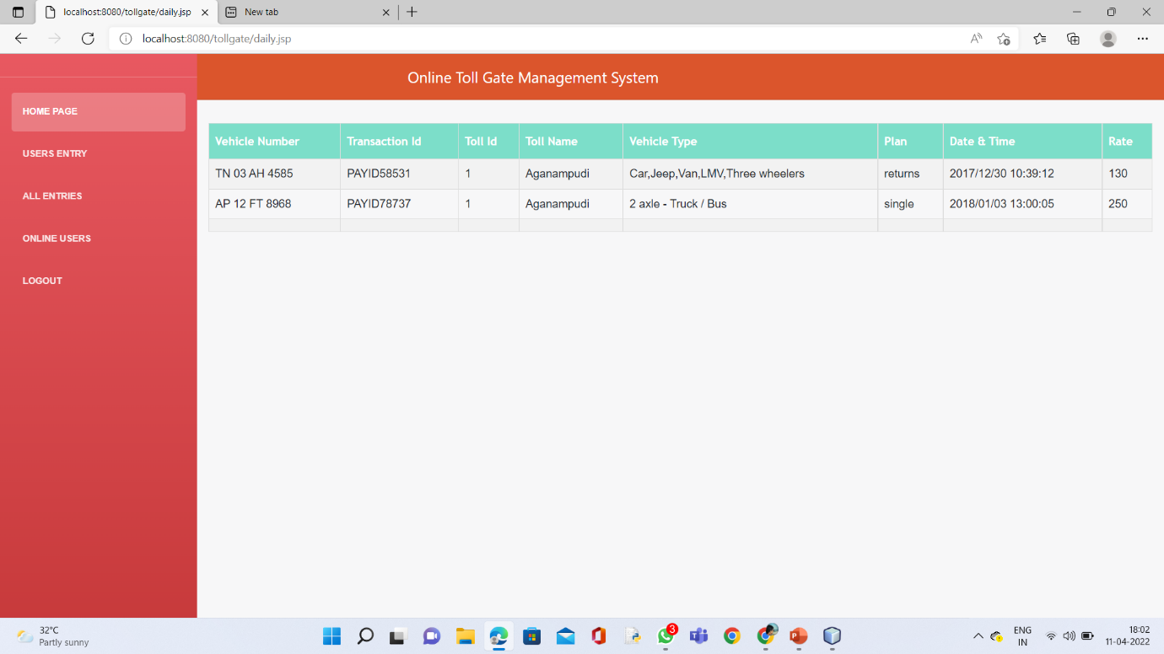

Figure 32

Online Users:

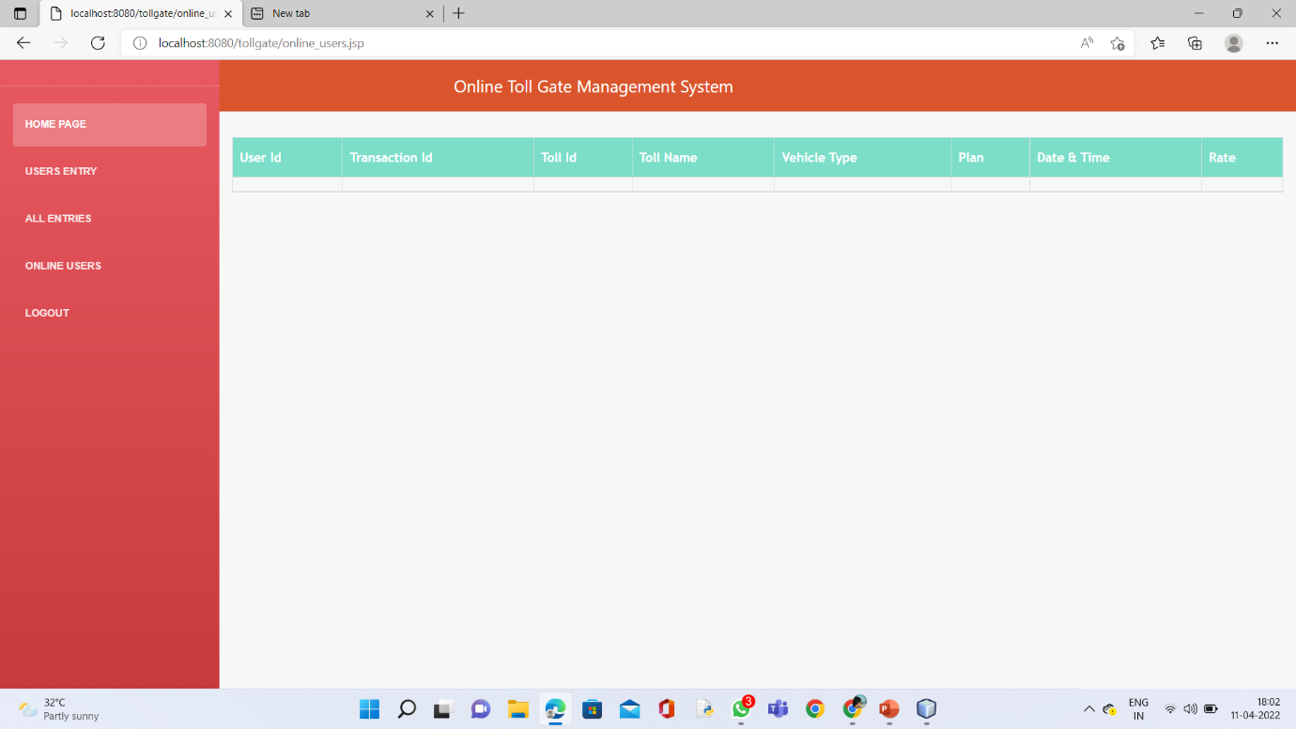

Figure 33

Users Home page:

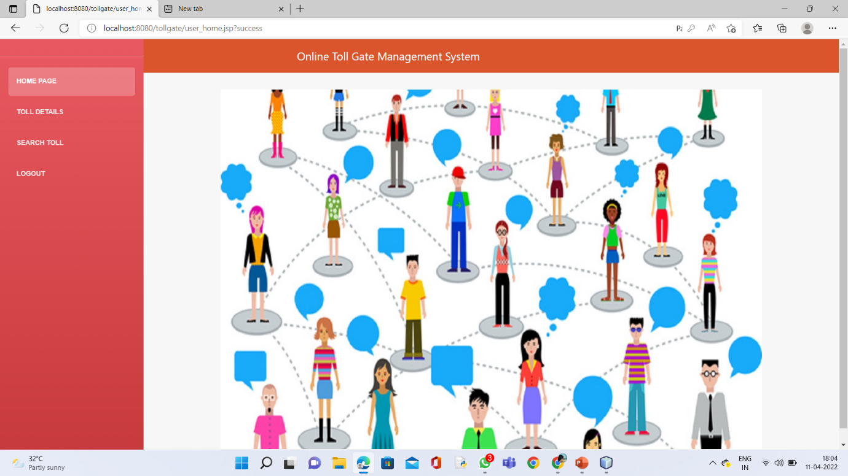

Figure 34

Registration Page:

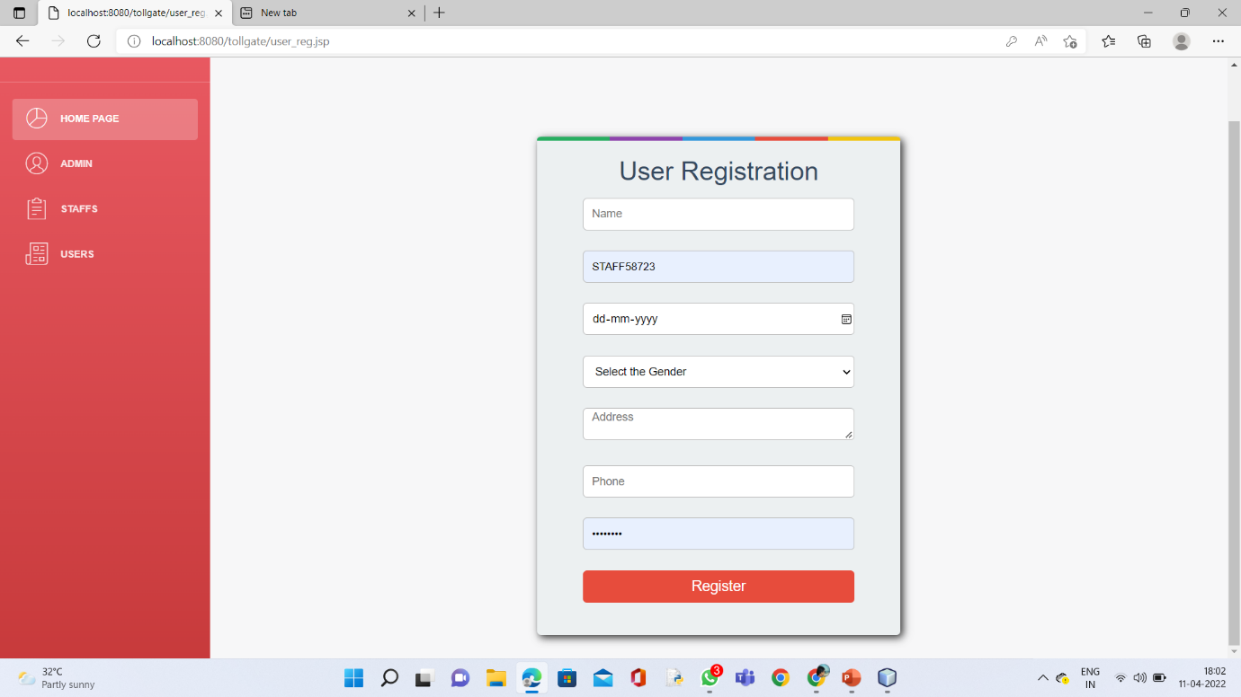

Figure 35

Toll Details:

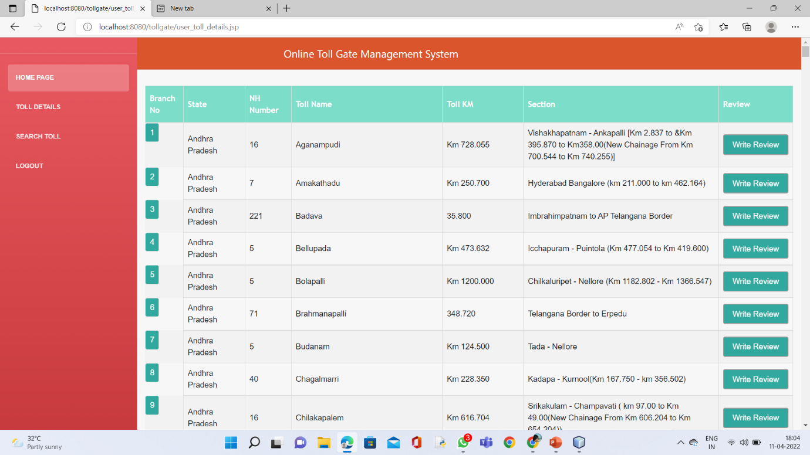

Figure 36

Search Details:

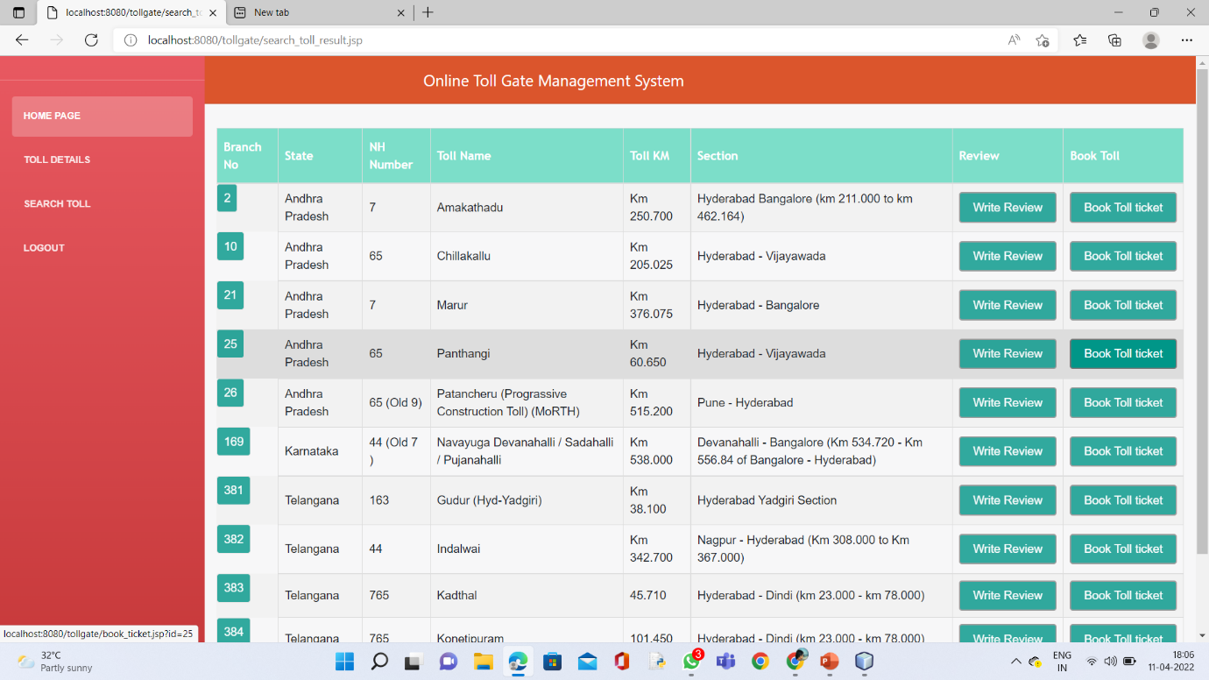

Figure 37

Search Toll:

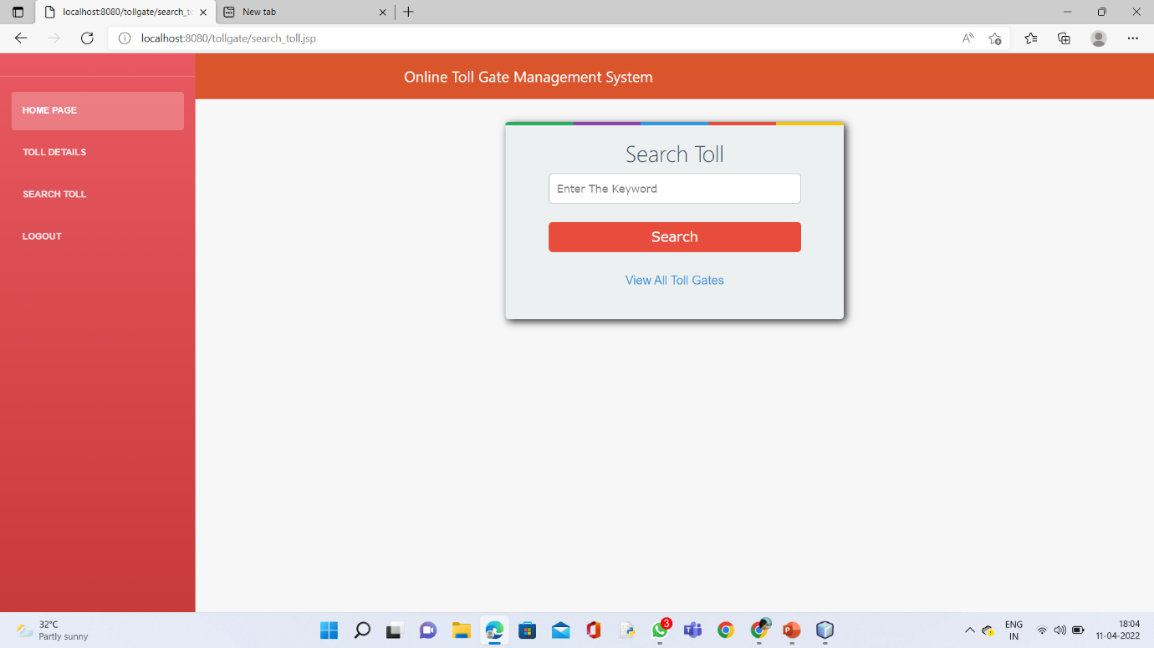

Figure 38

User Payment Page:

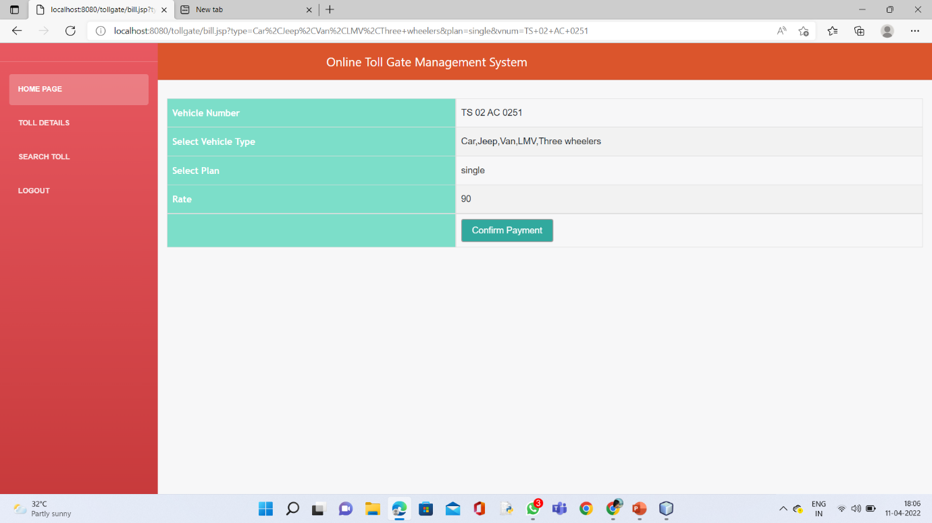

Figure 39

**10.SYSTEM REQUIREMENTS:**

**HARDWARE REQUIREMENTS:**

* System : Pentium IV 2.4 GHz.
* Hard Disk : 40 GB.
* Floppy Drive : 1.44 Mb.
* Monitor : 15 VGA Colour.
* Mouse : Logitech.
* Ram : 512 Mb.

**SOFTWARE REQUIREMENTS:**

* Operating system : - Windows XP/7.
* Coding Language : JAVA/J2EE
* Data Base : MYSQL

**Reference**

**• www.google.com**

**• www.wikipedia.com**

**•** [**www.youtube.com**](http://www.youtube.com)

* **Github Link:** https://github.com/pavankumar1681/Onlinetollgate-management-system.git

**11.CONCLUSION**

The package was designed in such a way that future modifications can be done easily. The following conclusions can be deduced from the development of the project.

* + Automation of the entire system improves the efficiency
  + It provides a friendly graphical user interface which proves to be better when compared to the existing system.
  + It gives appropriate access to the authorized users depending on their permissions.
  + It effectively overcomes the delay in communications.
  + Updating of information becomes so easier.
  + System security, data security and reliability are the striking features.